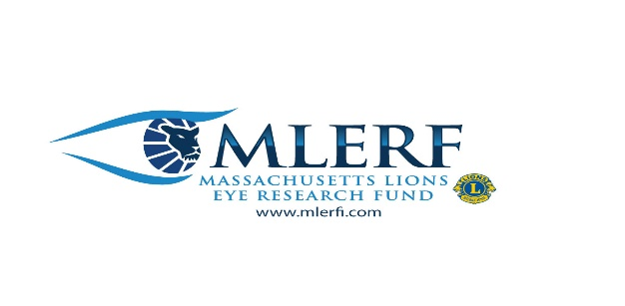
2022 MLER Calendar – Featuring Photos from Lions
Across the Multiple!
Questions? Call PDG Pat Kalicki 508-533-2770 or
pak331@aol.com
Thank you for supporting MLERF. With your support, academic and medical institutions in Boston, are making great strides in preventing and curing vision-related diseases and blindness.
MASS LIONS EYE RESEARCH IS A 501C3 Charity.
The calendars make great gifts for club members, family and friends! A great way for clubs to raise money for MLER.
$12.00 each

MLER CALENDARS WILL GO ON SALE ON NOVEMBER 1st.
To reserve your copy(s), cut out this section and enclose with your check made out to: “MLERF”
Mail form & check to:
PDG Pat Kalicki,
4 Thayer Rd, Medway, MA 02053
Name:_________________________
Address:_______________________
City,State, Zip:___________________
Club_______________ District__________
# of calendars:__________
Total due $_____________($12.00 each)
*Clubs will be credited as a donation to MLER, for some of the sales

