In support of Massachusetts (MD33) Lions hosting activities of the Lions Club International Convention in Boston 2023

LCICON 2023 BOSTON Donation Pledge
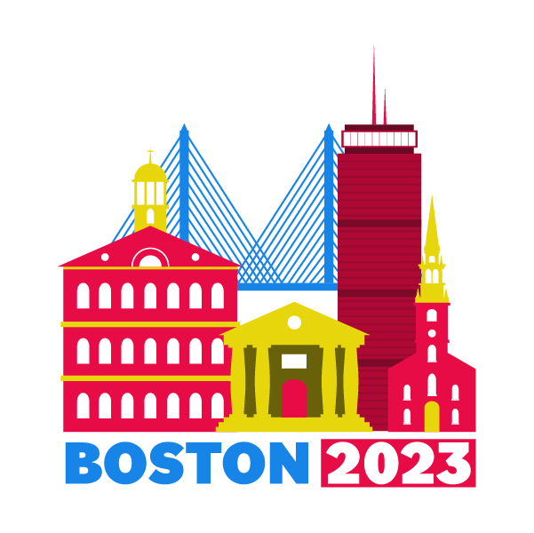

Donor Information (please print or type)

Individual’s Name

Club Name:

District Name:

Billing address

City, State, Zip Code

Phone

Email

Donation/Pledge Information
I (we) pledge a total of $____________________ to be paid over 3 Lions Years:
2020-2021: $____________________
2021-2022: $____________________
2022-2023: $____________________
I (we) will make this contribution in the form of: ☐cash ☐check

Acknowledgement Information
Please use the following name(s) in all acknowledgements:

☐I (we) wish to have our donation remain anonymous.
Signature(s) |  | Date
Please make checks payable to: |  | LCICON 2023 Boston  PO Box 8343  Haverhill, MA 01835-9992

