LCICON 2023 BOSTON
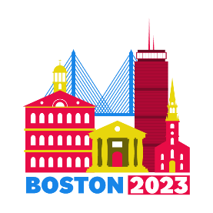
JULY 7 - JULY 11
BOSTON, MASSACHUSETTS
105TH LIONS CLUB INTERNATIONAL 2023 CONVENTION-BOSTON, MA

Picture this!!! Lions and friends from all over the world converging in Boston.

Boston is hosting the 2023 Lions Club International convention.

The last convention in America took place in Las Vegas and the next one is in Boston. What a great way to showcase our beautiful city. Opportunity for those Lions of MA who have never attended a convention to attend and participate and get to meet Lions from all over the world.

The anticipated attendance for an International Convention is between 35,000-45,000, because of Covid, attendance is expected to surpass this number.

A Steering Committee has been set up, Chair: PID Joyce Middleton, Vice Chair: PCC Joyce Hogan. Committees are being formed, so volunteers are needed.

Need plenty of volunteers from Lions of Massachusetts. Volunteer signup on the website.

Website: www.lcicon2023boston.com

Great opportunity for Lions to participate/volunteer as a club which would give them a service project.

Letters & Pledge forms have been mailed to all of the clubs in the Massachusetts. Asking all clubs and Lions to consider donating and/or pledging funds over the next three years to help defray the expenses of this convention. To stage a first class event, need to raise between $150K-$200K. Income will be generated from corporate sponsors, Host committee sales, Band deposits, fundraisers and the Lions of MD33.

It’s not too early volunteer and make your donations. Checks should be made payable to LCICON2023 Boston. Complete the donation/pledge form and mail it to:
LCICON2023 Boston
P. O. Box 8343
Haverhill, MA 01835-9992

District Liaisons: PDG Margaret Menard (mimbeau@yahoo.com) Please contact with any questions.

